King Fahd University of Petroleum and Minerals

Department of Systems Engineering

CISE 301: Numerical Methods

Term 201

**Computer Home Work # 1**

**Date Assigned: Sunday, 25th October 2020**

**Due Date: Midnight of Saturday, 15th November 2020 (Through Blackboard)**

**Total Score: 20 points**

**Notes:**

* Use MATLAB to write code in order to solve the following questions.
* Cheating from any other student and/or website is strictly prohibited and will result in losing all your points. Your evaluation will include being able to explain your code.
* Two people are allowed to work as a group, and it is enough for one of you to submit the assignment, but make sure to mention the name and student IDs of the group members in the report.

**Submission Items:**

1. A Word document in which you:
   1. Describe in brief the problem you are solving and the numerical method used.
   2. Snapshot of the output, when you run the program for the conditions mentioned in the questions.
   3. Discuss your results.
2. MATLAB code (.m) file(s)

**Question 1:** [10 points]

Write a MATLAB *function* that calculates the approximate value of arctan(*x*) using the Maclaurin series approximation:

$\arctan\left(x\right)=x-\frac{x^{3}}{3}+\frac{x^{5}}{5}-\frac{x^{7}}{7}+…$

The *function* should accept 3 parameters: value of $x$, number of significant figures accuracy i.e. $n$, and the maximum number of iterations. In the function, use $ε_{s}=\left(0.5×{10}^{2-n }\right)\%$ in order to continue until the $ε_{a}$ falls below this criteria. The *function* should return 3 values: the approximate value of arctan(*x*) at the end of the program, final $ε_{a}$ and the number of iterations it took.

Submit the snapshots showing the program running from the command prompt for *x* = 0.4 and 0.8.

**Solution**

I make a function which take three input and return three output as well. Three input as mention in the problem statement are initial value of x , significant figure accuracy and max number of iteration. Output are approximate value , iteration and nal_e_a.

I use the approach maclurin series. I use the while loop for the condition.

**Code**

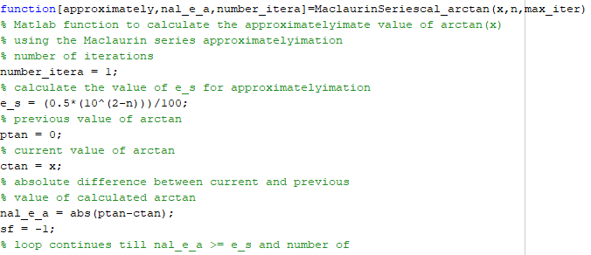

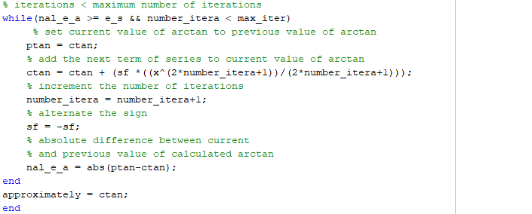

**Output**

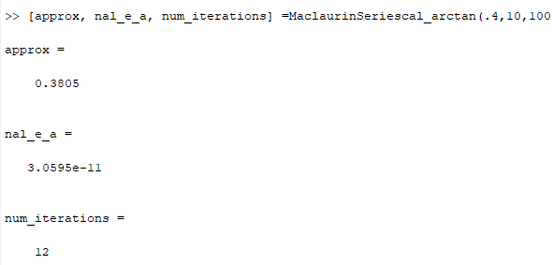

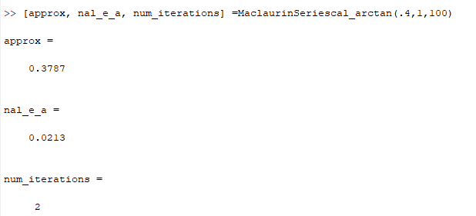

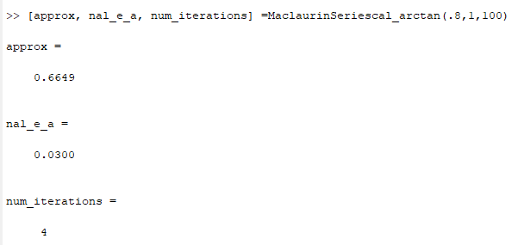

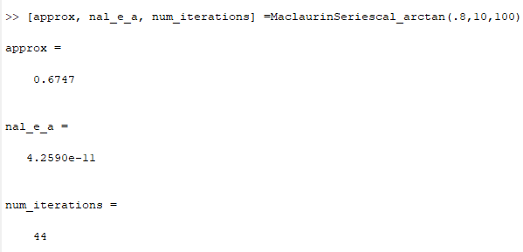

**Question 2:** [10 points]

Write a MATLAB *function* that uses Bisection Method to iteratively estimate the positive real root of the equation $\ln{(x^{4})}=0.7$ in the interval [*xl*, *xu*] until *εa* is less than *εs.* Note that $x$ is in radians.

The *function* should accept 3 parameters: initial *xl*, *xu,* and *εs*, and return these 5 parameters for each iteration: $x_{l}, x_{u}, x_{r}$*Sign*{$f\left(x_{l}\right)f(x_{r})\}$ and *εa*. (Hint: Function should return arrays instead of single values).

Please write a script which gives output in the following tabular form for the developed function using $x_{l}=0.5$, $x_{u}=2$ and *εs* = 0*.*1%. Submit the snapshot of the output of the script.

|  |  |  |  |  |  |
| --- | --- | --- | --- | --- | --- |
| Iteration | $$x_{l}$$ | $$x_{u}$$ | $$x_{r}$$ | Sign{ $f\left(x_{l}\right)f(x_{r})\}$ | *εa* (in %) |
| 0 |  |  |  |  |  |
| 1 |  |  |  |  |  |
| 2 |  |  |  |  |  |
| $$⋮$$ |  |  |  |  |  |

Note: See figure 5.11 for the pseudocode of Bisection Method.

**Solution**

As mention in the question we need to solve the equation by using bisection method, $\ln{(x^{4})}=0.7$ become as

ln(x4)-0.7=0

In first we need to find the solution of the equation on minimum value and maximum value. If both multiply and result is not greater than 0 we can find the roots by using bisection method. Because both root are require in different sign like any one is positive and other must be negative.

At the end calculate the value at every iteration until tolerance criteria not meet.

**Code**

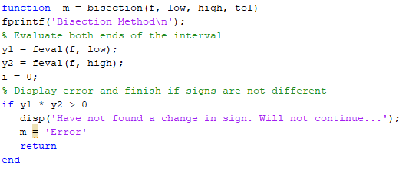

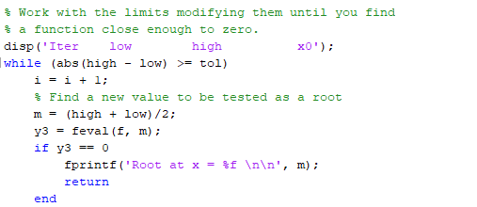

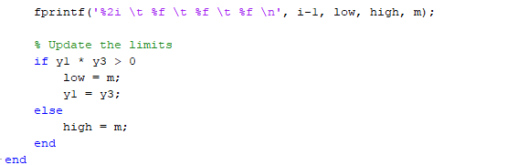

**Output**

